January Promotion
Lamingtons

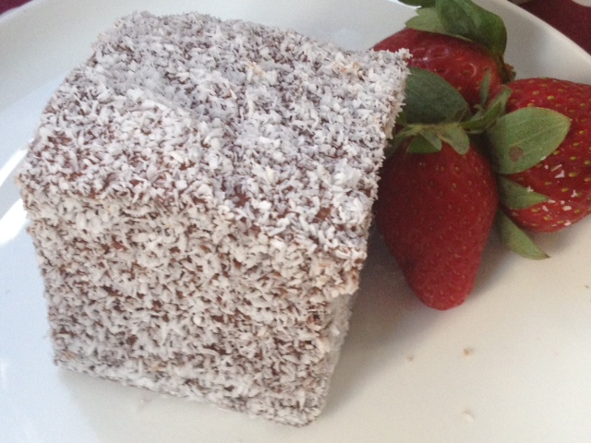

$5.00 per Pack of six
Please email orders to gumnut@sbctc.com.au

Name: ……………………………………………………………………. Phone No: ……………………………………………
Delivery Date: ……………………………………………………….. Payment method: COD / Direct Debit

Collection point:- CTC HQ CTC Employment Services Kingaroy
CTC Youth Kingaroy Gumnut Place, Murgon

22 Gore Street Murgon Qld 4605
Telephone: 07 41681852 Fax: 41681931

